4.4 Relational database systems

- ER MODEL DEFINITION
ENTITY
ATTRIBUTES
RELATIONSHIP
SYMBOLS
CARDINALITIES
Draw ERD for Bakery Management System.

FATIMA EJAZ BARRI

- ER models definition
An entity-relationship diagram (ERD) is a data modelling technique that graphically illustrates an information system’s entities and the relationships between those entities. An ERD is a conceptual and representational model of data used to represent the entity framework infrastructure. Also known as ERD, ER Diagram or ER model, is a type of structural diagram for use in database design. However, ER Diagram includes many specialized symbols, and its meanings make this model unique
Here are some typical use cases.
- Database design - Depending on the scale of change, it can be risky to alter a database structure directly in a DBMS. To avoid ruining the data in a production database, it is important to plan the changes carefully. ERD is a tool that helps. By drawing ER diagrams to visualize database design ideas, you have a chance to identify the mistakes and design flaws, and to make corrections before executing the changes in the database.
- Database debugging - To debug database issues can be challenging, especially when the database contains many tables, which require writing complex SQL in getting the information you need. By visualizing a database schema with an ERD, you have a full picture of the entire database schema. You can easily locate entities, view their attributes and identify the relationships they have with others. All these allow you to analyse an existing database and to reveal database problems easier.
- Database creation and patching - Visual Paradigm, an ERD tool, supports a database generation tool that can automate the database creation and patching process by means of ER diagrams. Therefore, with this ER Diagram tool, your ER design is no longer just a static diagram but a mirror that reflects truly the physical database structure.
- Aid in requirements gathering - Determine the requirements of an information system by drawing a conceptual ERD that depicts the high-level business objects of the system. Such an initial model can also be evolved into a physical database model that aids the creation of a relational database, or aids in the creation of process maps and data flow modes.

Components of the ER Diagram
This model is based on three basic concepts:
- Entities
- Attributes
- Relationships
Example
For example, in a University database, we might have entities for Students, Courses, and Lecturers. Student’s entity can have attributes like Roll no, Name, and Dept. ID. They might have relationships with Courses and Lecturers.
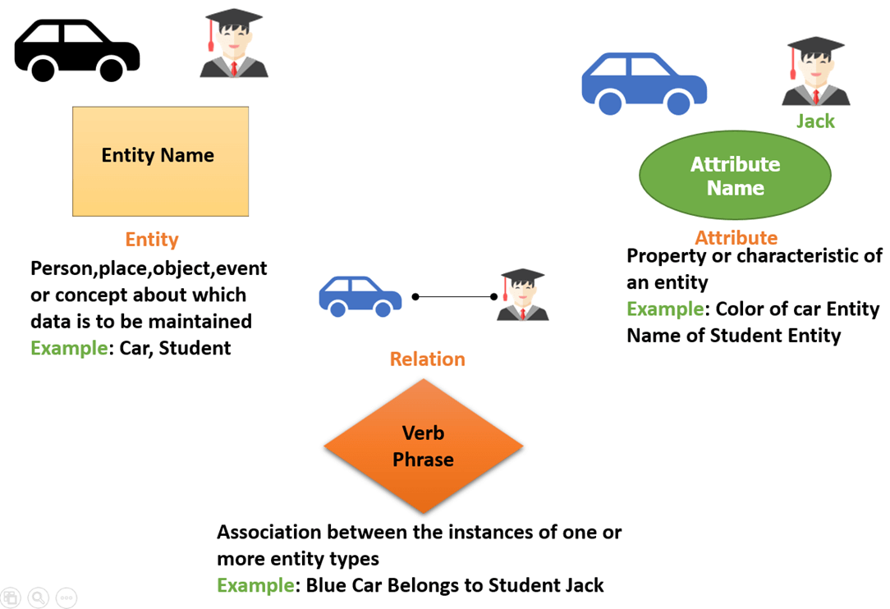

- Entity
A real-world thing either living or non-living that is easily recognizable and non recognizable. It is anything in the enterprise that is to be represented in our database. It may be a physical thing or simply a fact about the enterprise or an event that happens in the real world.
An entity can be place, person, object, event or a concept, which stores data in the database. The characteristics of entities are must have an attribute, and a unique key. Every entity is made up of some ‘attributes’, which represent that entity.
Examples of entities:
- Person: Employee, Student, Patient
- Place: Store, Building
- Object: Machine, product, and Car
- Event: Sale, Registration, Renewal
- Concept: Account, Course

Entity set:
Student
An entity set is a group of similar kind of entities. It may contain entities with attribute sharing similar values. Entities are represented by their properties, which also called attributes. All attributes have their separate values. For example, a student entity may have a name, age, class, as attributes.
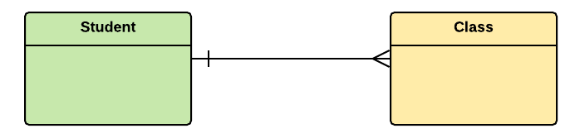
Example of Entities:
A university may have some departments. All these departments employ various lecturers and offer several programs.
Some courses make up each program. Students register in a particular program and enrol in various courses. A lecturer from the specific department takes each course, and each lecturer teaches a various group of students.

Attributes

Attributes are the properties which define the entity type. For example, Roll_No, Name, DOB, Age, Address, Mobile_No are the attributes which defines entity type Student. In ER diagram, attribute is represented by an oval.

Key Attribute –
The attribute which uniquely identifies each entity in the entity set is called key attribute.For example, Roll_No will be unique for each student. In ER diagram, key attribute is represented by an oval with underlying lines.

Composite Attribute –
An attribute composed of many other attribute is called as composite attribute. For example, Address attribute of student Entity type consists of Street, City, State, and Country. In ER diagram, composite attribute is represented by an oval comprising of ovals.

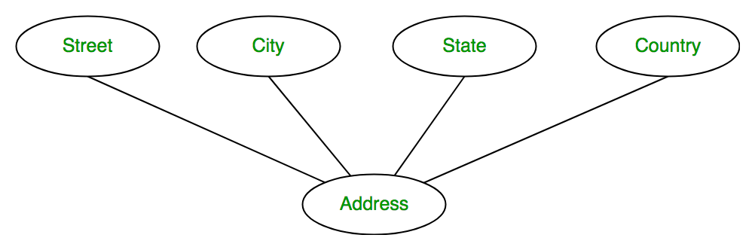

Multivalued Attribute –
An attribute consisting more than one value for a given entity. For example, Phone_No (can be more than one for a given student). In ER diagram, multivalued attribute is represented by double oval.

Derived Attribute –
An attribute which can be derived from other attributes of the entity type is known as derived attribute. e.g.; Age (can be derived from DOB). In ER diagram, derived attribute is represented by dashed oval.

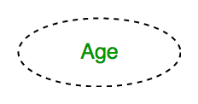

The complete entity type Student with its attributes can be represented as:

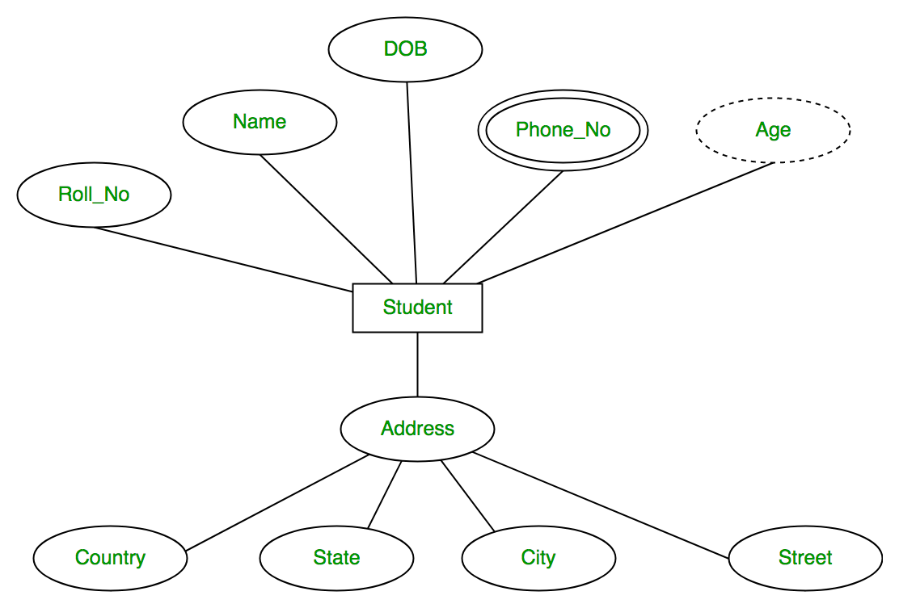

Primary Key
Also known as PK, a primary key is a special kind of entity attribute that uniquely defines a record in a database table. In other words, there must not be two (or more) records that share the same value for the primary key attribute. The ERD example below shows an entity 'Product' with a primary key attribute 'ID', and a preview of table records in the database. The third record is invalid because the value of ID 'PDT-0002' is already used by another record.
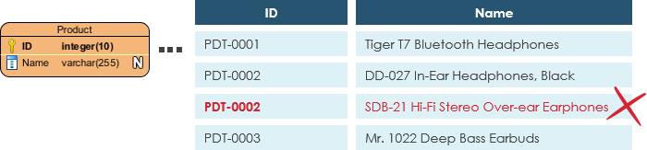

Foreign Key
Also known as FK, a foreign key is a reference to a primary key in a table. It is used to identify the relationships between entities. Note that foreign keys need not be unique. Multiple records can share the same values. The ER Diagram example below shows an entity with some columns, among which a foreign key is used in referencing another entity.

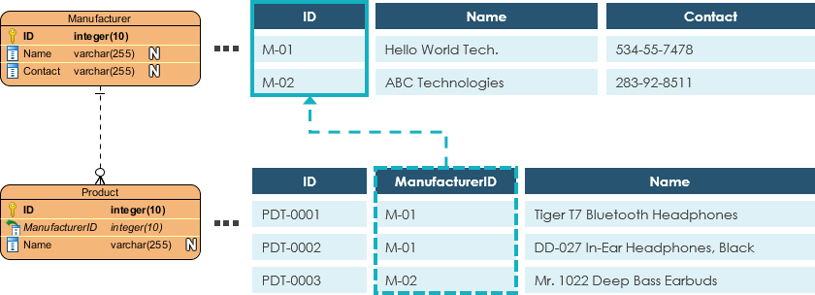

Relationship
A relationship between two entities signifies that the two entities are associated with each other somehow. For example, a student might enrol in a course. The entity Student is therefore related to Course, and a relationship is presented as a connector connecting between them

Cardinality
Cardinality defines the possible number of occurrences in one entity which is associated with the number of occurrences in another. For example, ONE team has MANY players. When present in an ERD, the entity Team and Player are inter-connected with a one-to-many relationship.
In an ER diagram, cardinality is represented as a crow's foot at the connector's ends. The three common cardinal relationships are one-to-one, one-to-many, and many-to-many.

One-to-One cardinality example
A one-to-one relationship is mostly used to split an entity in two to provide information concisely and make it more understandable. The figure below shows an example of a one-to-one relationship.
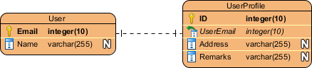

One-to-Many cardinality example
A one-to-many relationship refers to the relationship between two entities X and Y in which an instance of X may be linked to many instances of Y, but an instance of Y is linked to only one instance of X. The figure below shows an example of a one-to-many relationship.
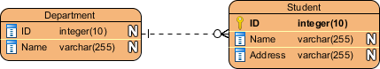

Many-to-Many cardinality example
A many-to-many relationship refers to the relationship between two entities X and Y in which X may be linked to many instances of Y and vice versa. The figure below shows an example of a many-to-many relationship. Note that a many-to-many relationship is split into a pair of one-to-many relationships in a physical ERD. You will know what a physical ERD is in the next section.

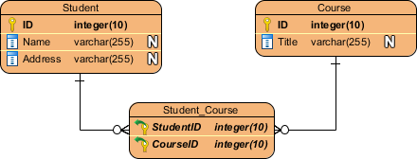

Conceptual, Logical and Physical data models
An ER model is typically drawn at up to three levels of abstraction:
- Conceptual ERD / Conceptual data model
- Logical ERD / Logical data model
- Physical ERD / Physical data model
- While all the three levels of an ER model contain entities with attributes and relationships, they differ in the purposes they are created for and the audiences they are meant to target.
- A general understanding to the three data models is that business analyst uses a conceptual and logical model to model the business objects exist in the system, while database designer or database engineer elaborates the conceptual and logical ER model to produce the physical model that presents the physical database structure ready for database creation. The table below shows the difference between the three data models.
- Conceptual model vs Logical model vs Data model:

ERD features | Conceptual | Logical | Physical
Entity (Name) | Yes | Yes | Yes
Relationship | Yes | Yes | Yes
Columns |  | Yes | Yes
Column's Types |  | Optional | Yes
Primary Key |  |  | Yes
Foreign Key |  |  | Yes

Conceptual data model
Conceptual ERD models the business objects that should exist in a system and the relationships between them. A conceptual model is developed to present an overall picture of the system by recognizing the business objects involved. It defines what entities exist, NOT which tables. For example, 'many to many' tables may exist in a logical or physical data model but they are just shown as a relationship with no cardinality under the conceptual data model.

Conceptual data model example

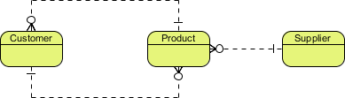

Logical data model
Logical ERD is a detailed version of a Conceptual ERD. A logical ER model is developed to enrich a conceptual model by defining explicitly the columns in each entity and introducing operational and transactional entities. Although a logical data model is still independent of the actual database system in which the database will be created, you can still take that into consideration if it affects the design.

Logical data model example

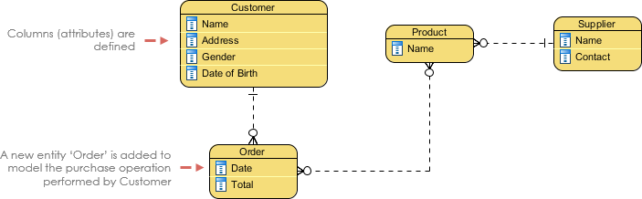

Physical data model
Physical ERD represents the actual design blueprint of a relational database. A physical data model elaborates on the logical data model by assigning each column with type, length, nullable, etc. Since a physical ERD represents how data should be structured and related in a specific DBMS it is important to consider the convention and restriction of the actual database system in which the database will be created. Make sure the column types are supported by the DBMS and reserved words are not used in naming entities and columns.

